FS80 + Ultra Light Bracket

Version 2.0

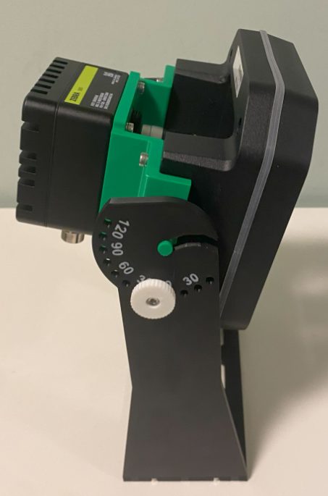

Table of Contents
Project goals 3
FS80+UL Bracket 4
FS80+UL Pivot Base 5
Mounting holes 6
Base rotation 6
Reinforcement holes 6
Shoulders 7
Design 7
Shoulder Base 7
Ribs and mounting holes 7
FS80 + UL Pivot Shoulder Right 8
FS80 + UL Pivot Shoulder Left 9
Final result 10
For Next Iteration 11
Reference 12

Project goals
Create a support bracket for Zebra FS80 and Ultra Light illuminator that can be easy to mount and easy to use in lab or mounted on Bosch profiles. Since it is 3D Printed from plastic it is not intended for permanent installations.
Key point are:
- Lens are adjustable without removing from the camera.
- The camera can be removed without changing the system orientation.
- The orientation use a fixed set of angles, all 15 degree apart are available so the angle is always 100% replicate.
- The bracket can be mounted on a 90 x 45 mm Bosch profile, on both sides.
- The mounted camera and illuminator are stable and balanced, so it is easy test different tilt angles without using the locking screws.
- The height is enough to let the cable pass through without excessive stress or forced bend.
- Camera and illuminator are fixed using just one set of screws: M4x10 Cylindrical Hex Screws.

Version 2.0
- Improve the bracket base to handle correctly the 90x45 mm Bosch Profile
  - Increase the base width from 60mm to 80 mm
  - Change the slots using rectangular shapes aligned with 90x45 Bosch Profile and T-Bolts
- Update the shoulders for the new base size and insert a hole in the center to store the knob when not in use.

Accessories

T-Bolts
These are the bolts used to fix the bracket to the Bosch Profile.
https://amzn.eu/d/byO3eKk
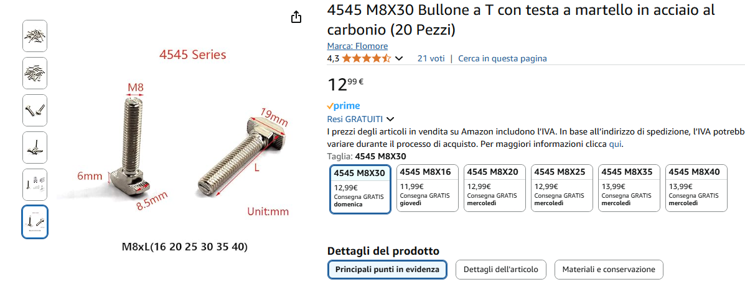

Flange Nut
These are the nuts suitable to lock the bolt in place.
https://amzn.eu/d/5xHTgVZ
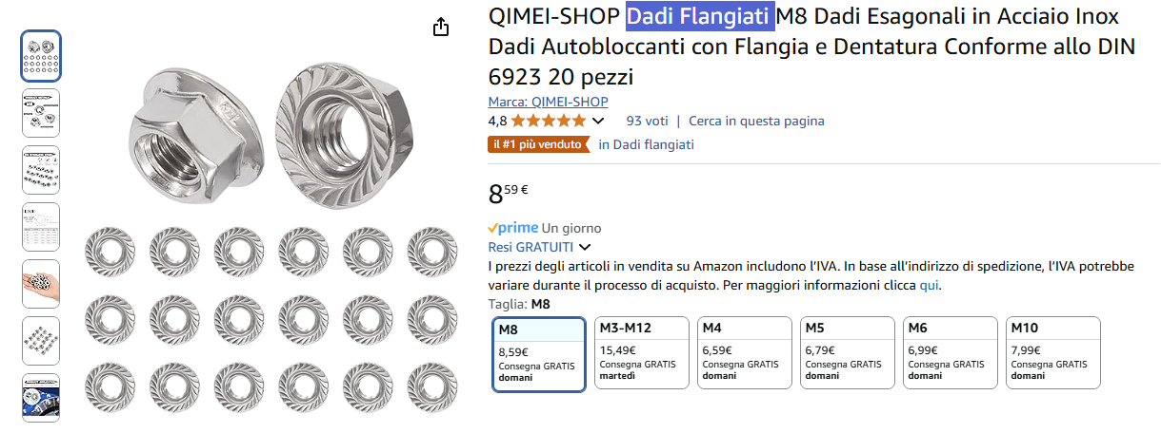

Components: FS80+UL adapter
This component connect the FS80 and the Ultra Light adapter.
I use multiple bends to gain enough space for the lens. The goal is to have the lens aligned with the LED protection. This to make possible the implementation of a polarized cover for both LED and Lens.
The position of the rotating pins has been calculated to provide a good balancing of the camera.
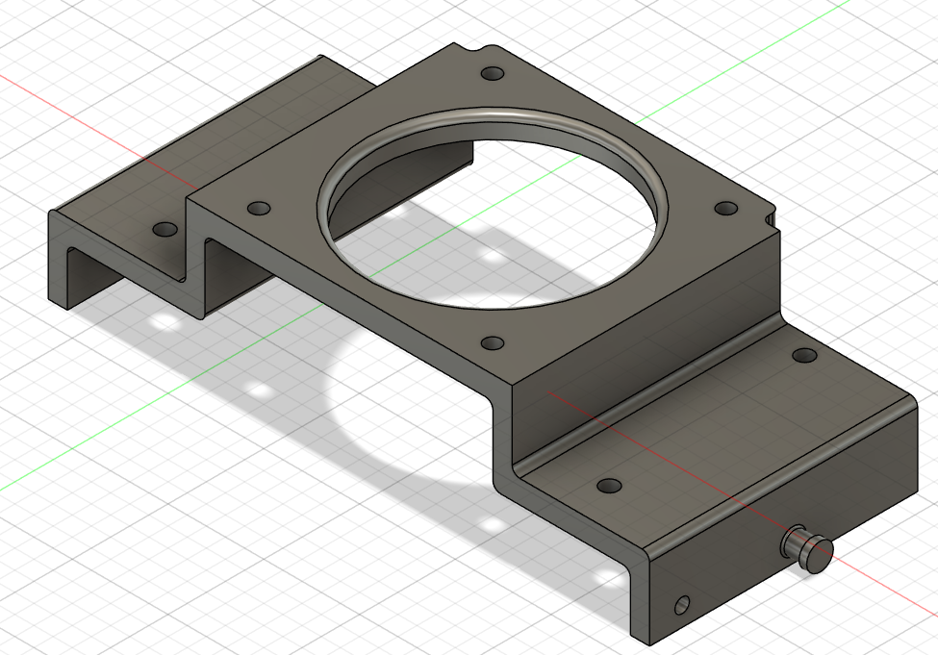
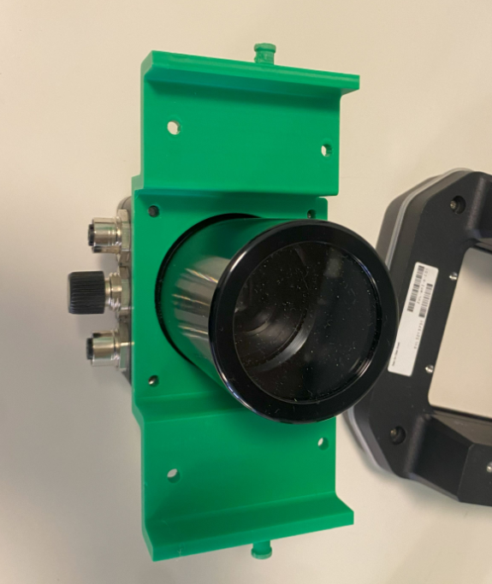 | 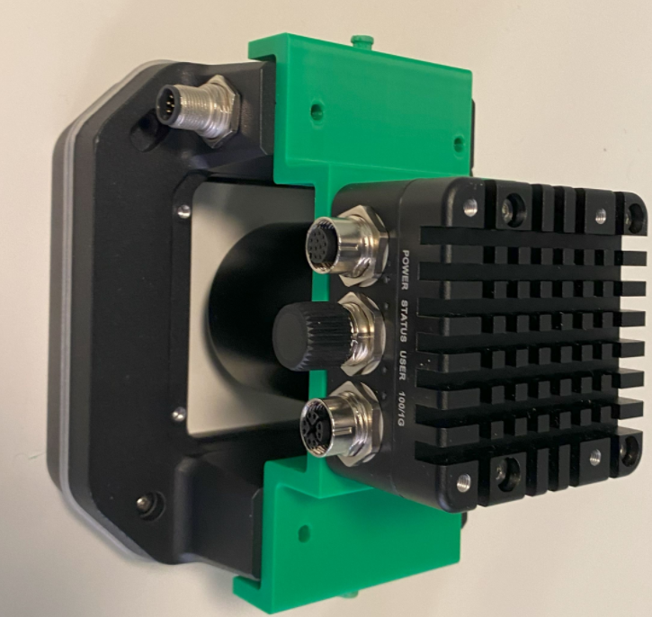

Components: FS80+UL Pivot Base - wip
In this 2.0 design we can handle the Bosch profile more easily
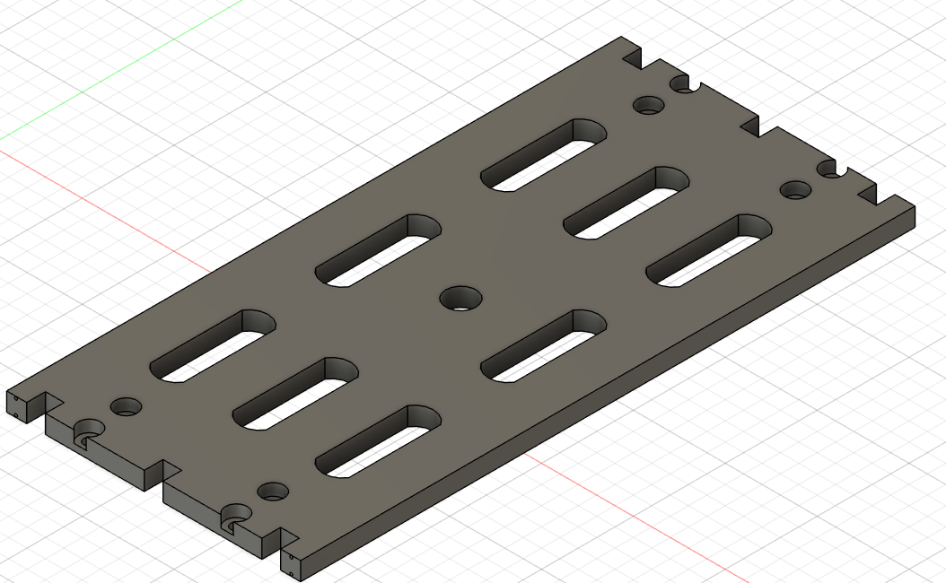

Mounting holes - wip
The base is assembled with the shoulder using 4 screws (4x M3x16) and a small slot in the center.
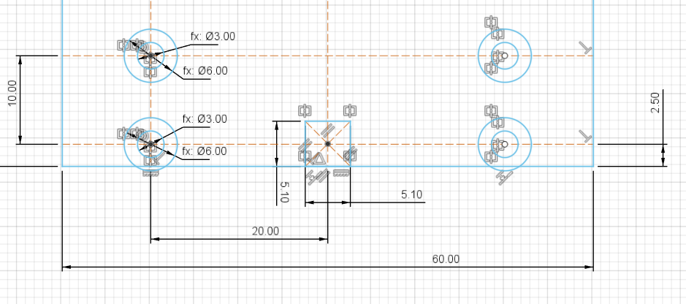

Reinforcement holes - wip
I created 4 holes in the base to force the slicer to add more material and make it more rigid.
The Holes are 0.8 mm and close to the top and bottom face to maximize the resistance.

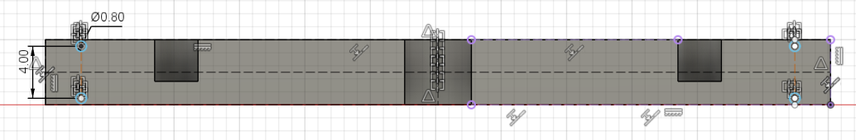

Bosch 90x45 installation and possible rotation
We can use 4 screws to lock the bracket in place.
And thanks to the rectangular slots we can align the bracket to the profile or place it into multiple orientations.
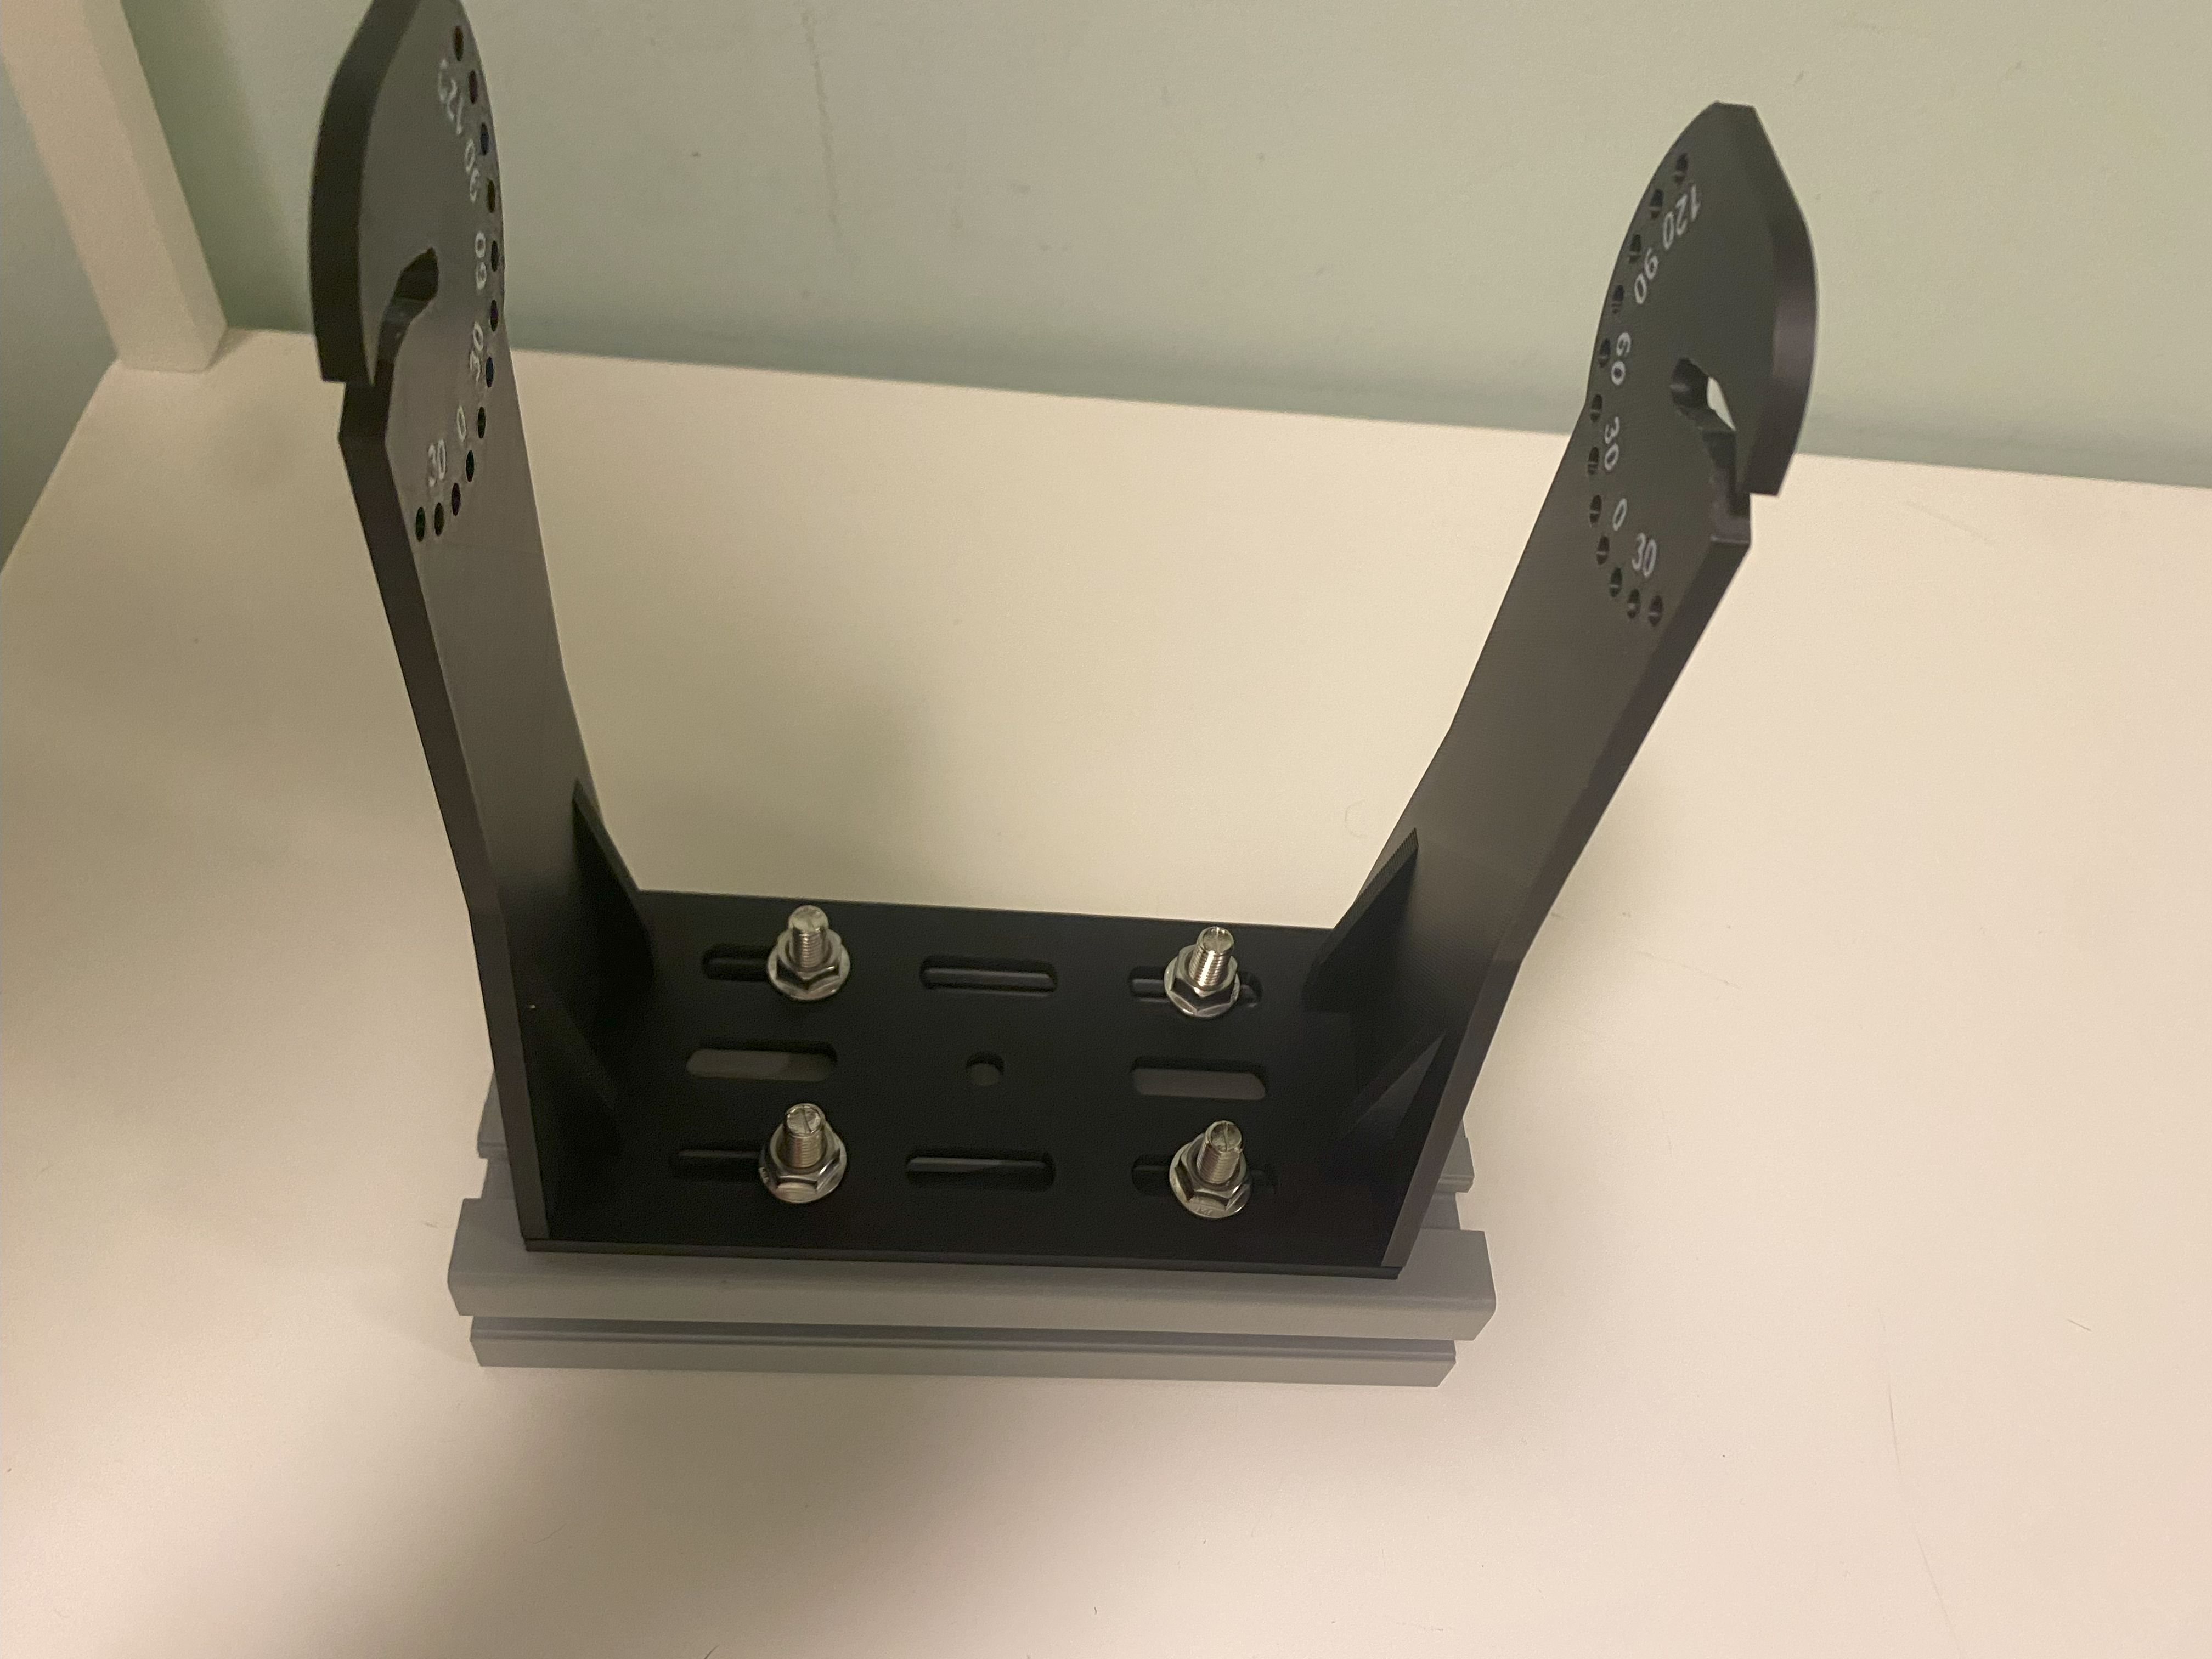 | 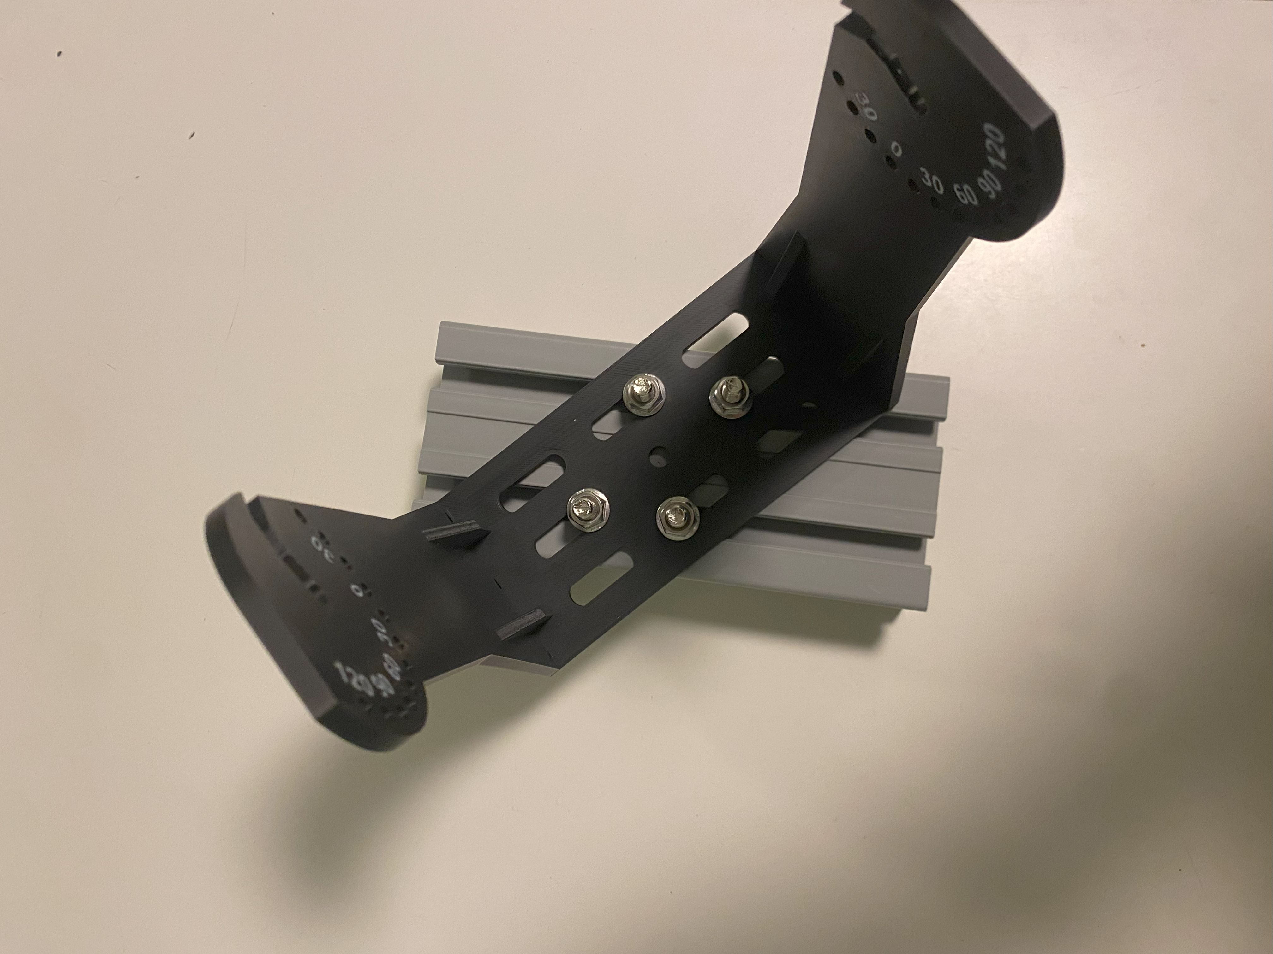

Bosch 90x45: Short Side Installation
The bracket can be fixed also to the short side using 2 screws.
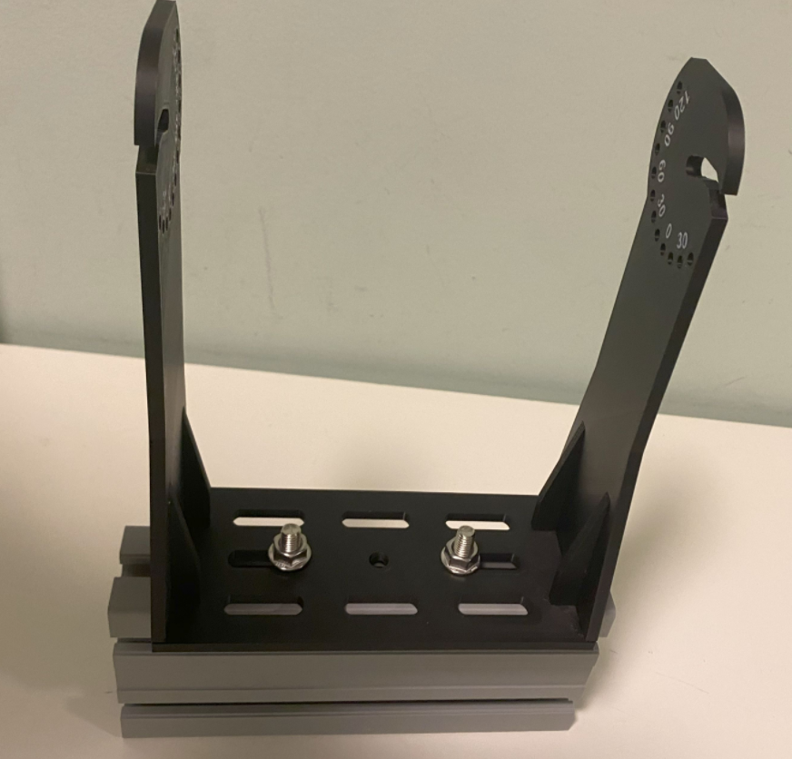

Shoulders wip

Design wip

Shoulder Base wip
I add 5 mm each side to reach 60 mm width. This makes possible to create a more stiff base plate and the dimension is the same as widely used 60 mm Bosch profiles.

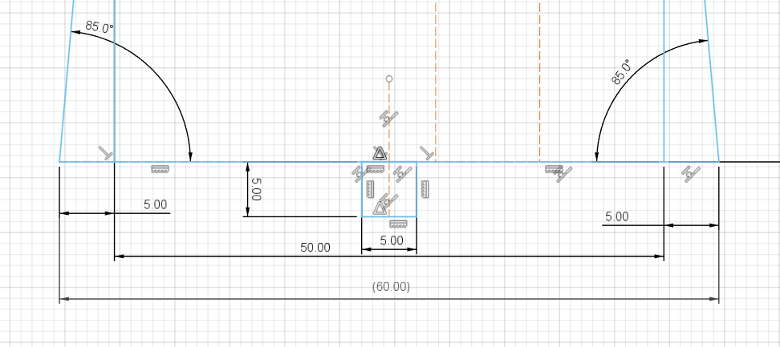

Ribs and mounting holes
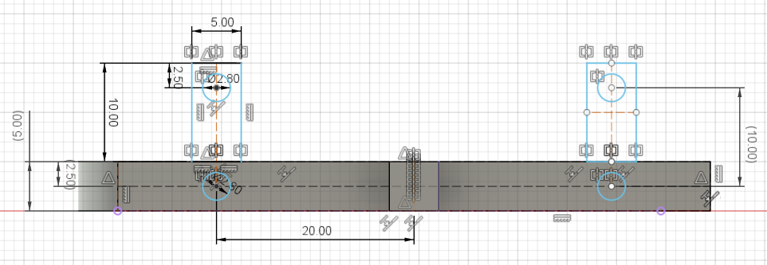

FS80 + UL Pivot Shoulder Right
This is the right shoulder from version 2.0.
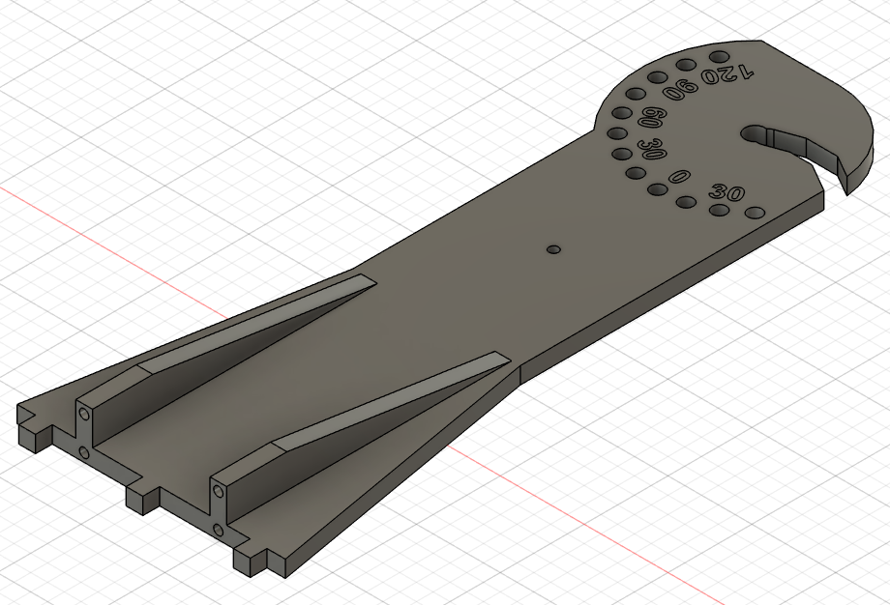

FS80 + UL Pivot Shoulder Left
This is the right shoulder from version 2.0.
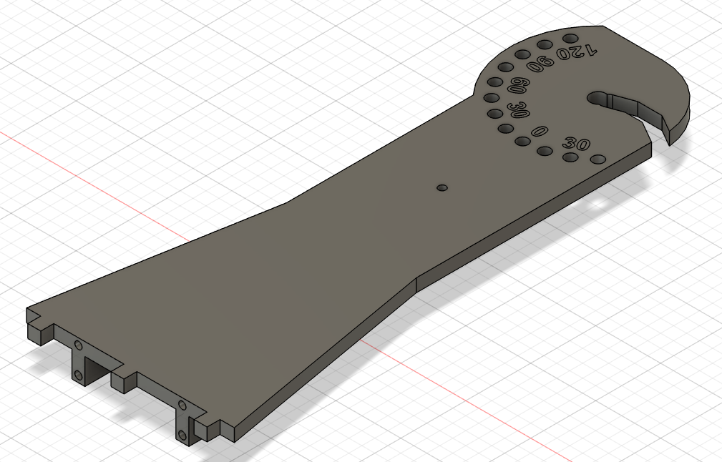

Final result WIP
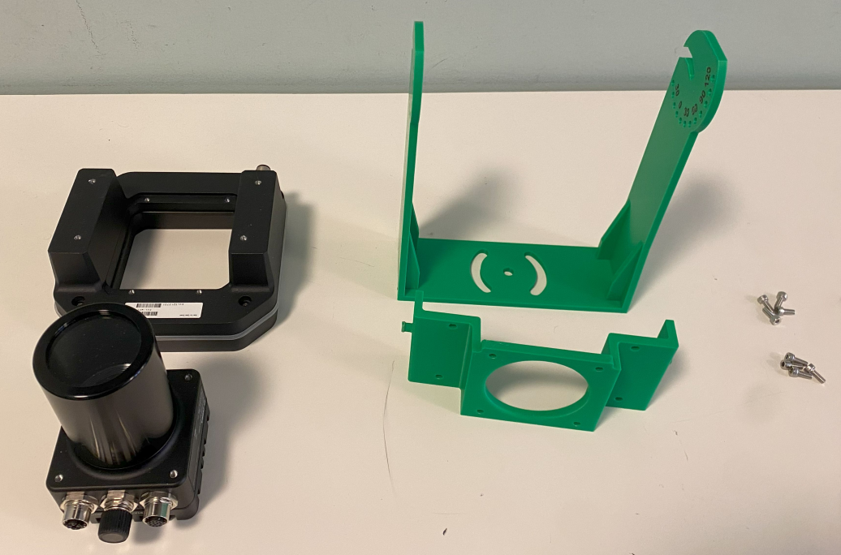

For Next Iteration
To be more error proof a small extrusion should be add to identify the correct bracket orientation.
This should be on the top side of the bracket so if we try to mount it upside down we can’t because of the connectors.
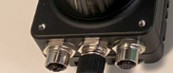 | 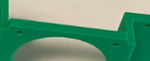

Reference

Bosch Rexrooth 45x90
This is an example of Bosch profile 90x45 mm: PROFILATO SAETTONE | 3842553615 | Bosch Rexroth

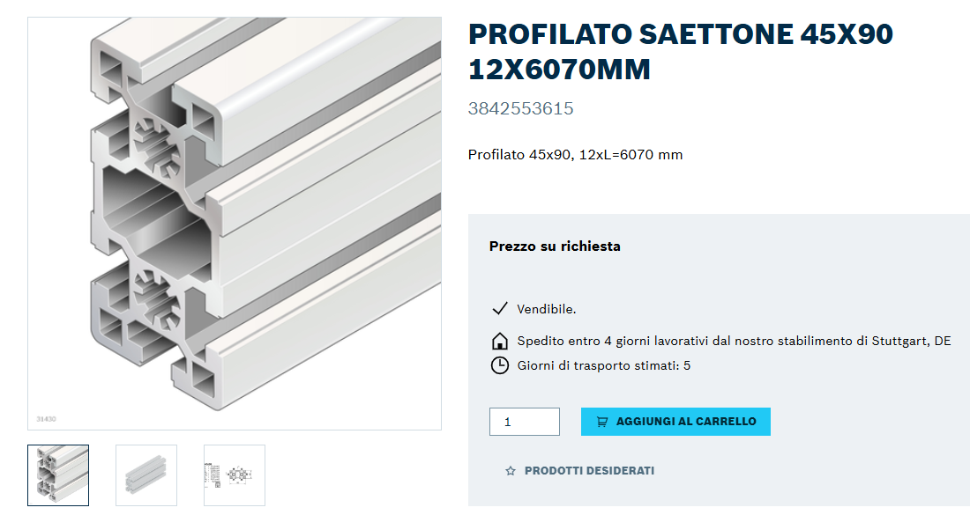

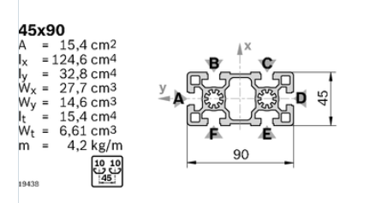

T-Bolt
https://www.amazon.it/dp/B07TKHNDX3?th=1
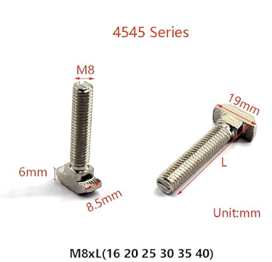

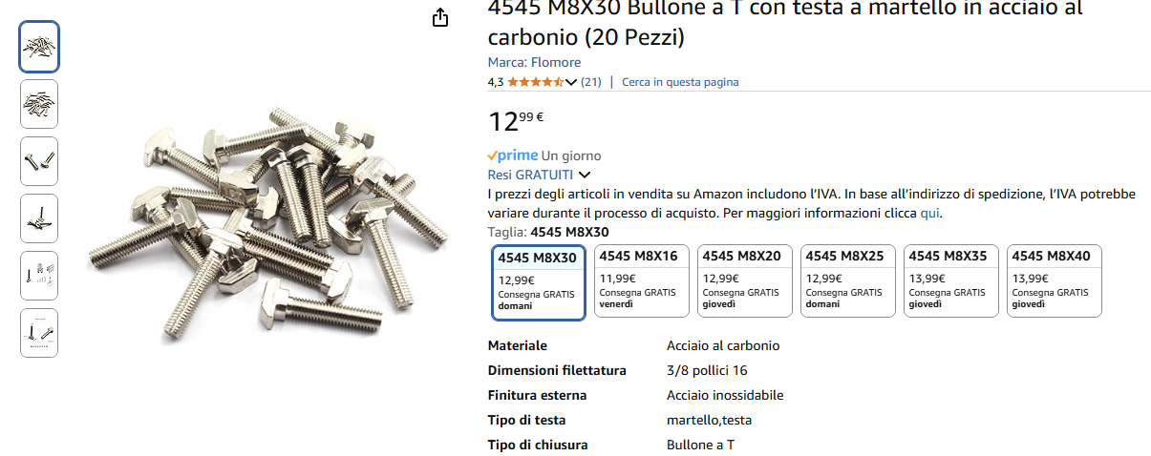

Robounits 40x80

NA 8020-1.5x3.0 Inches

